1] **pwd** (present working directory): This gives a view on present directory we are using

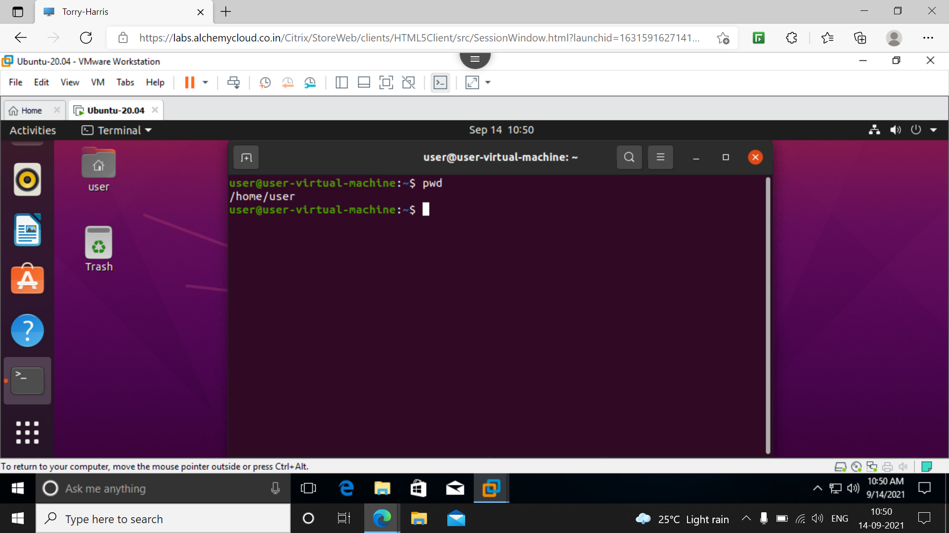

2] **ls** : list – it gives the details of all list present In directory in the foll eg. The pwd is home and it showing all list in home like dektop, documents, downloads, etc.

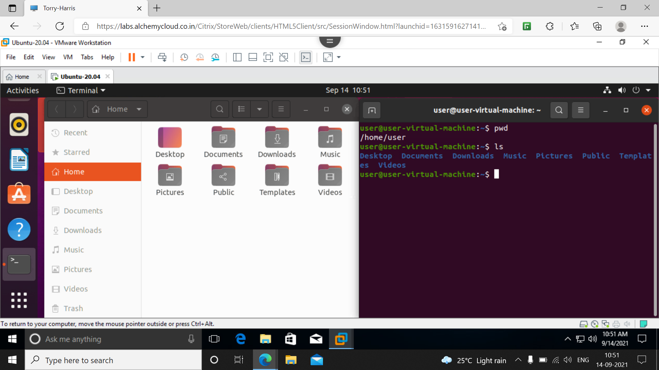

3] **ls –l** : it will give the details of list what it contains and when it was created, date time and also the folder is readable and writable. 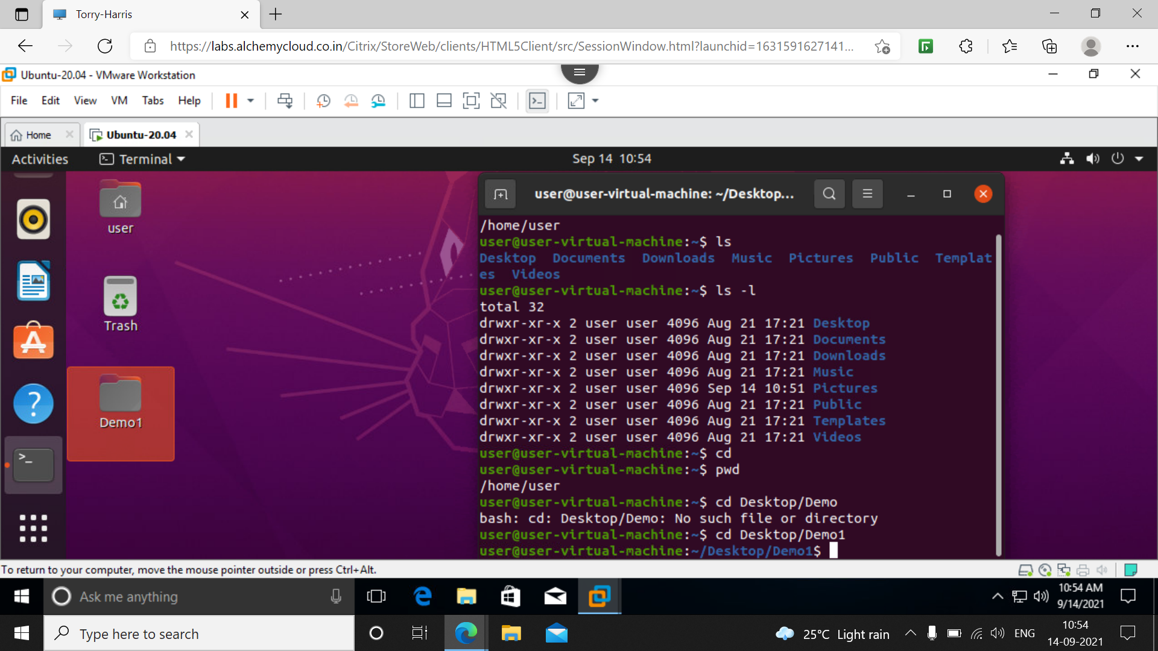

4] **cd**: change directory when we use cd command it will come to home directory wherever it may be.

5] **cd ..** : this command is used to go one step back. In following eg. The pwd was Demo1 after the use of command it came back to Desktop then again it came to home.

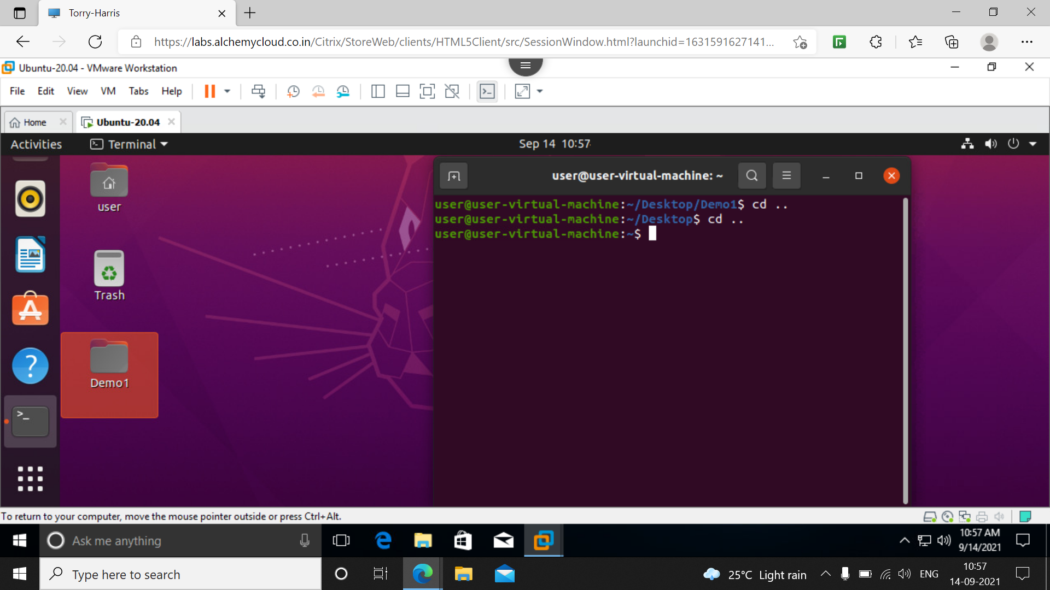

6] **cd /** : using cd / it will take us to root folder and the user will change from normal user to root user

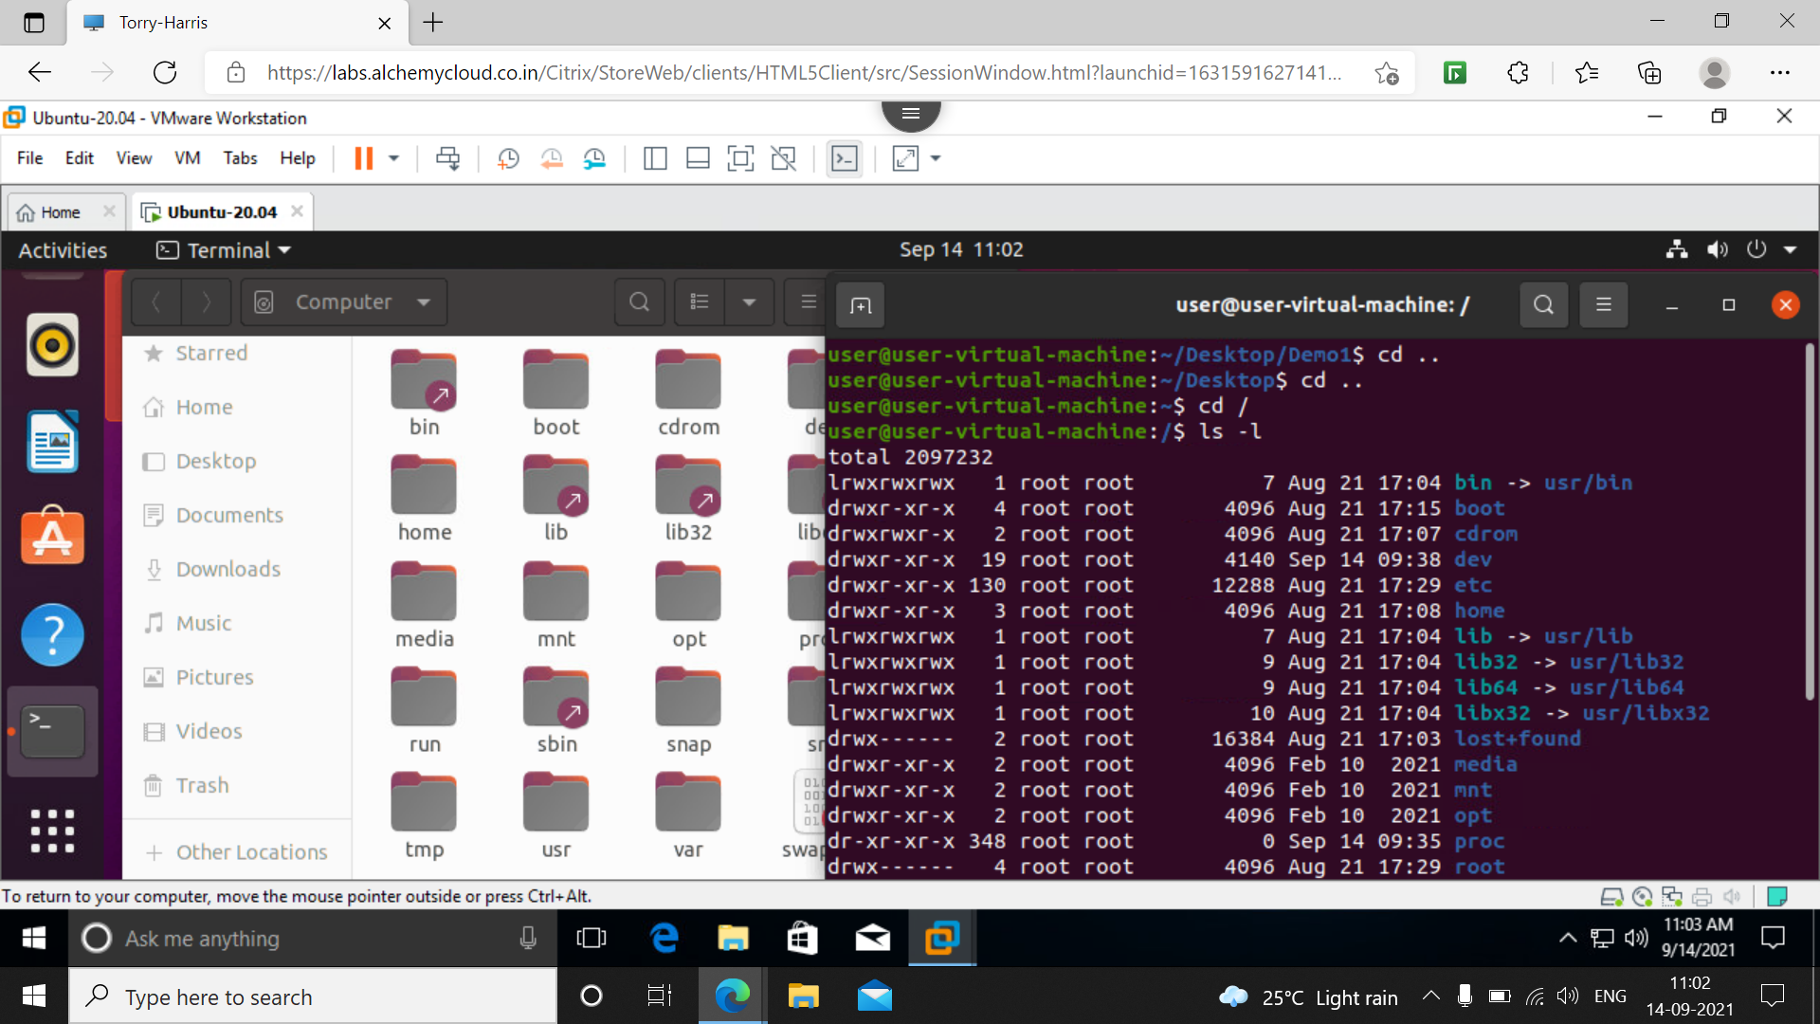

7] **ls –l** : inside root user gives the details of all folders.

8] **man** : it is used to get the manual of requested command

Eg, man ls : gives the manual of ls command and we use ‘q’ to quit the manual, similarly for man pwd for pwd manual

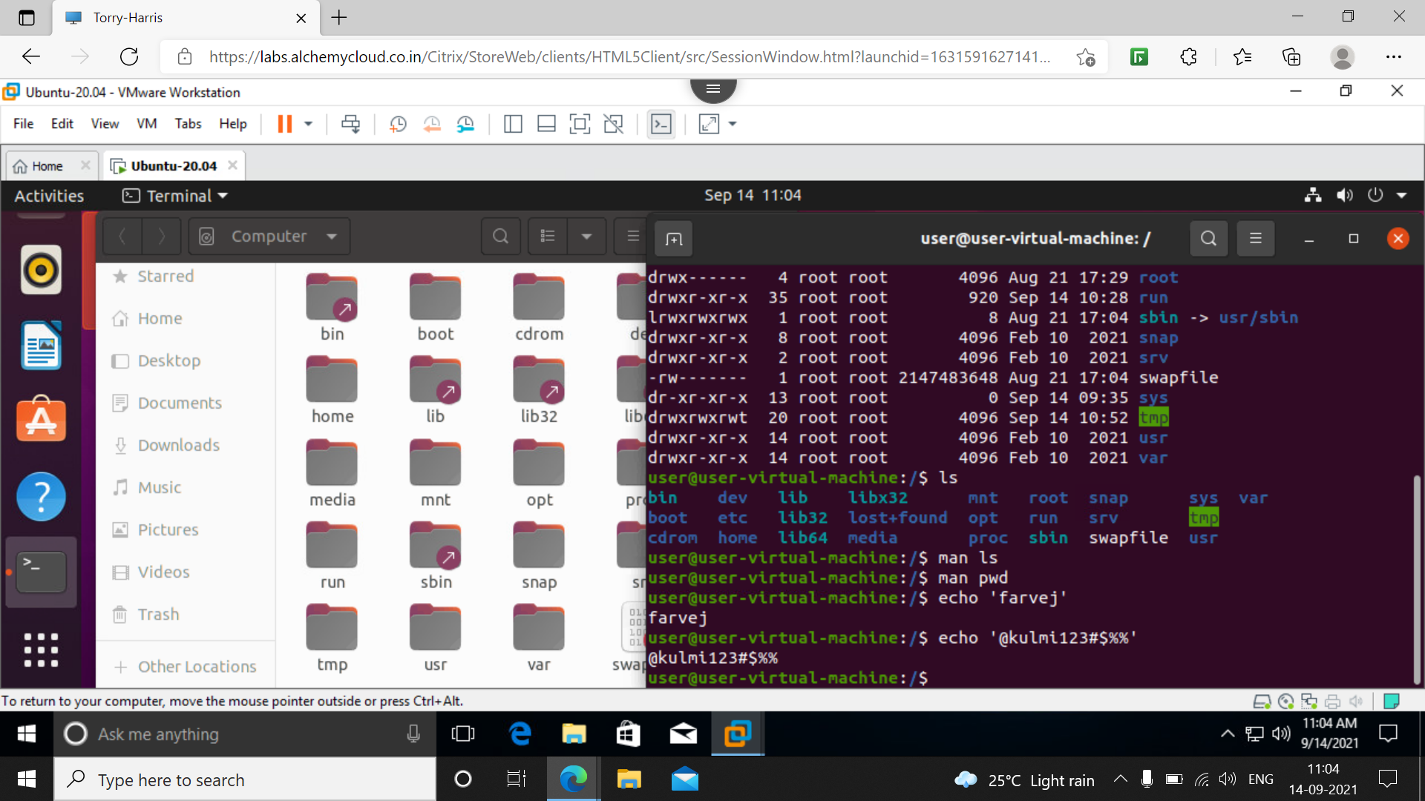

9] **echo**: this command is used to write some strings here we used echo ‘farvej’ to print farvej.



10] **mv oldname newname**: this mv is used to change the folder name. First we should note it is in correct directory. Here we changed the name from Demo12 to demo1 in Desktop directory.

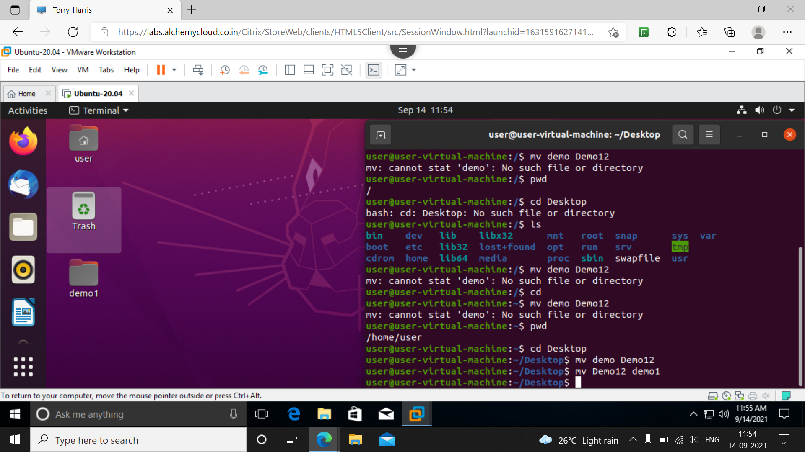

11] **clear** : used to clear all the data published on terminal.

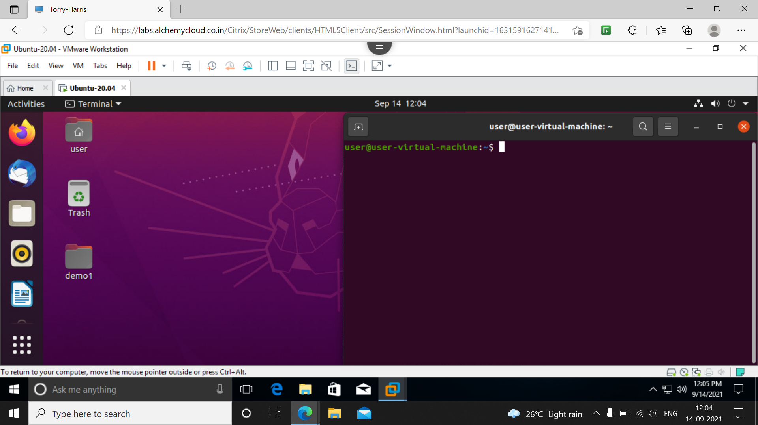

12] **exit**: this is used to exit from terminal. It wll come to home screen of ubuntu

13] **cat** : this is used to get the data from respective text file we want. Here in eg I have taken cat 3 which mean the text file 3 contents are displayed

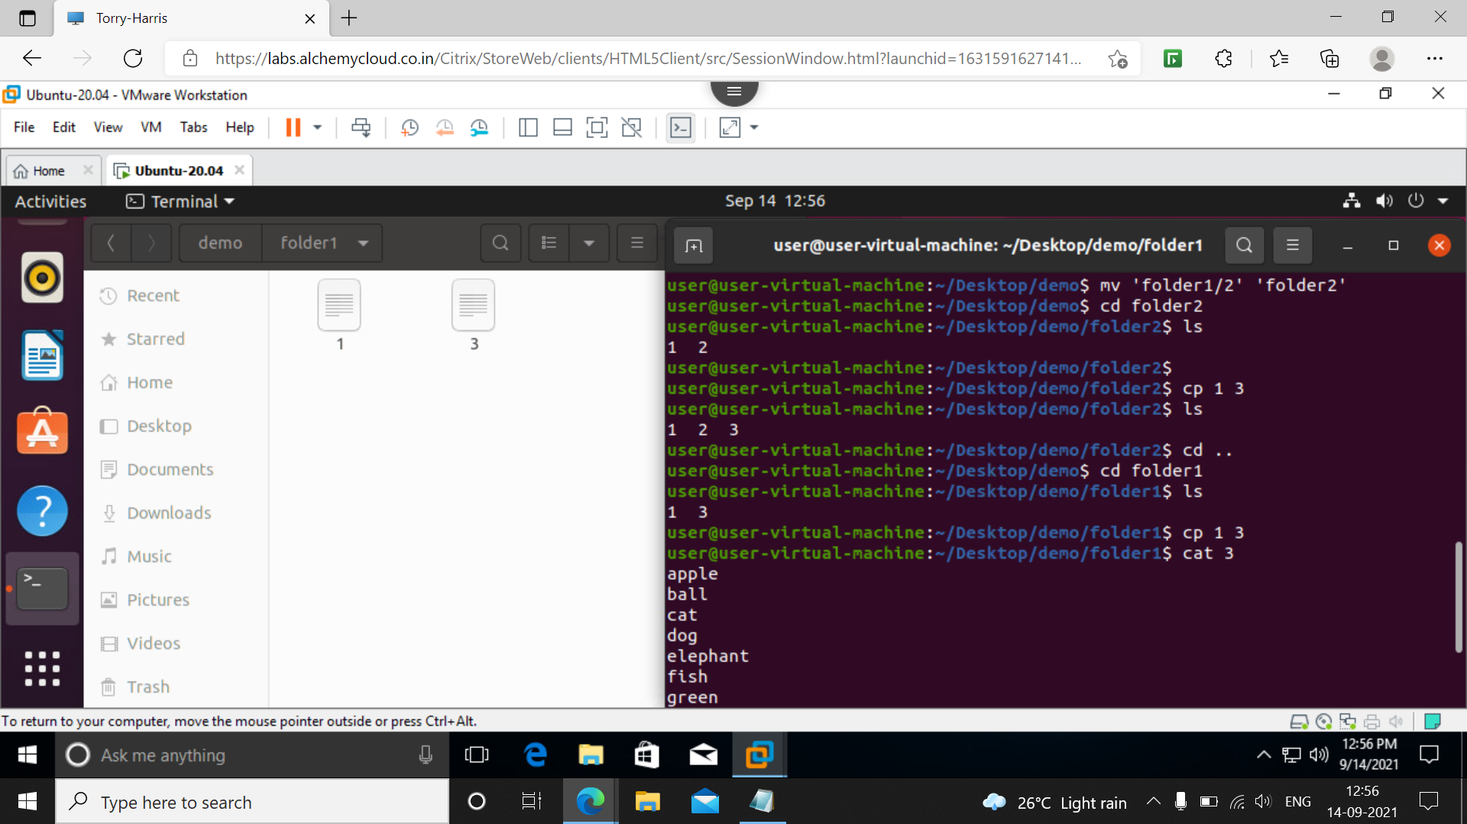

14] **date** : it is used to print the date and along with time as shown in screenshot.

In below its tuesday sept 14 2021 time is 12:50 IST

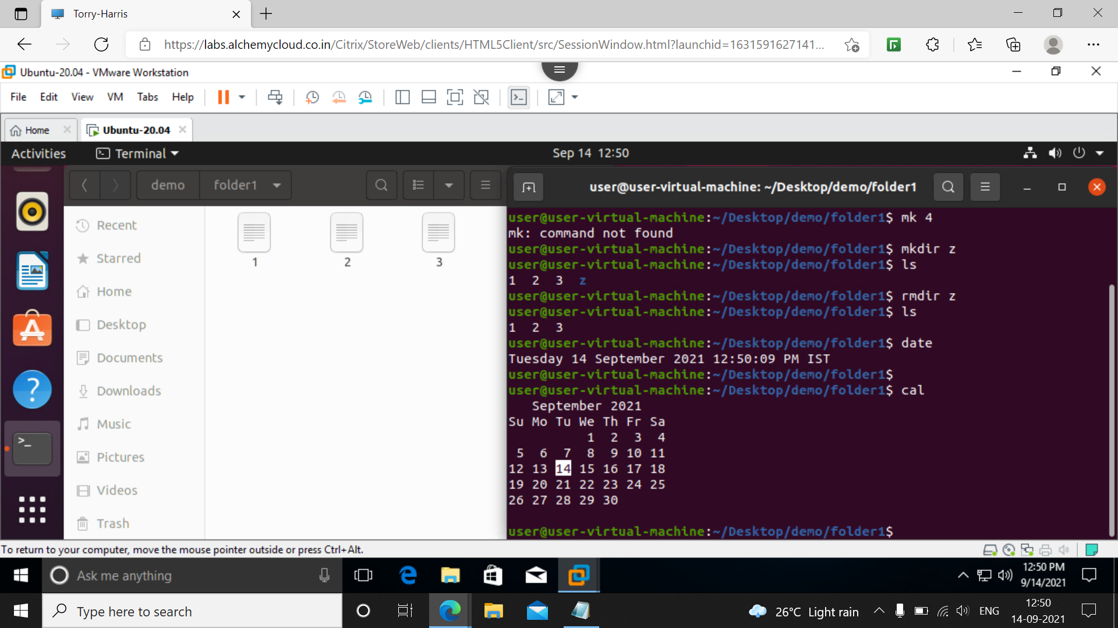

15] **cal** : stands for calender gives the date which is highlighted

In above screenshot date is highlighted as 14

16] **who** : this indicates who is using the virtual machine and the session also

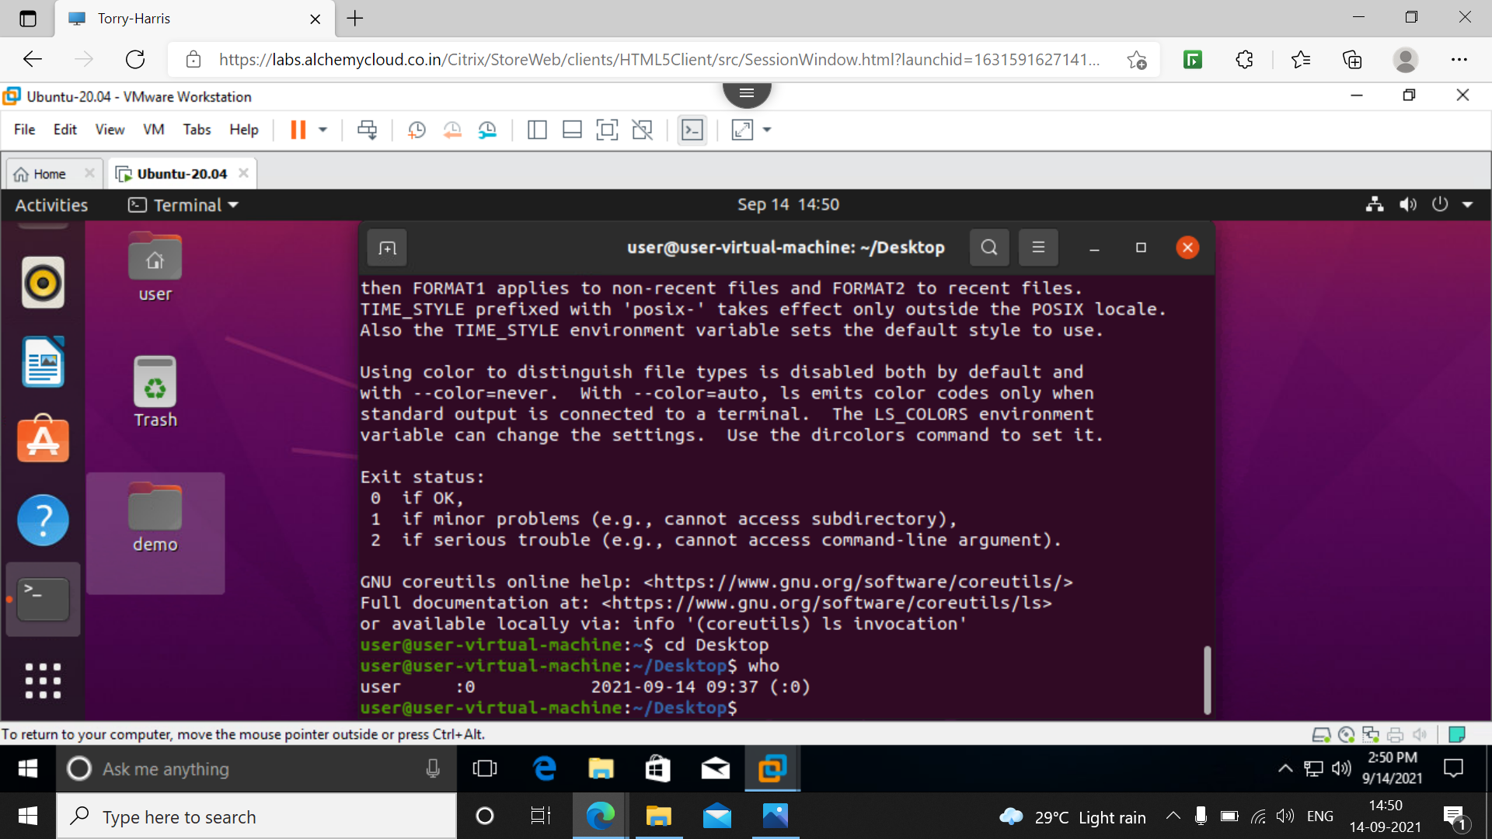

17]**cd foldername**: this command is used to navigate to desired folder

In below screenshot we have cd Desktop to goto Desktop as pwd

Next cd demo then cd folder1 after all this our current pwd is ‘Desktop/demo/folder1’

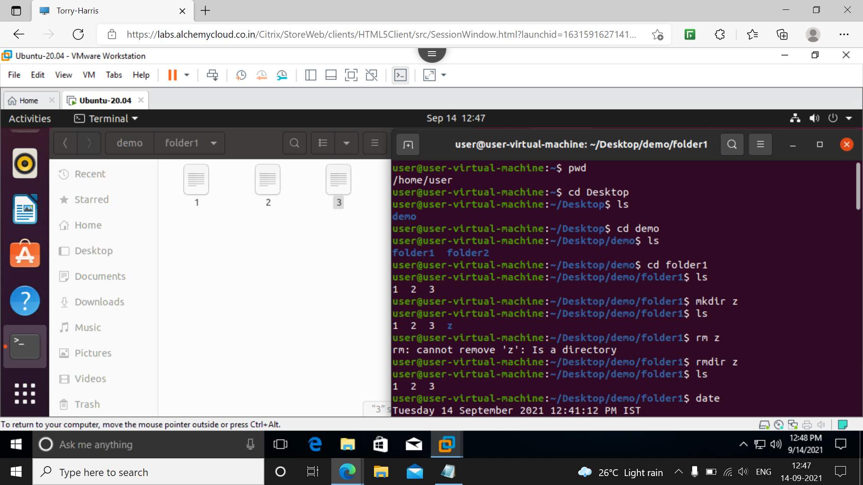

18] **mkdir** : to add a directory we use this command. Below we have mkdir z which creates z directory

On giving ls command we can see them z is added as directory.

19] **rmdir** : to remove a directory eg, rmdir z it removes z directory

Giving ls command we can check the contents in below screenshot.



20] **touch** : used to add file inside disired folder below we had only 1 3 files after using touch 2 a new file 2 is created and touch 4 5 added two new files on checking we had 1 2 3 4 5 files.

21] **rm** : used to remove a file from existing folder

Belove we have 1 2 3 4 5 as our file using rm 4 5 the files 4 and 5 got deleted on checking we had only 1 2 3 inside folder1.

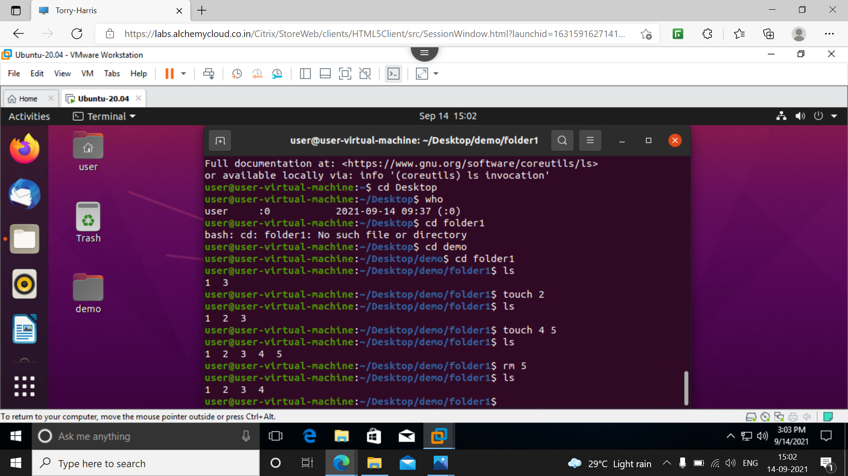

22**] cp** : used as copy command

In below screenshot I have copied the data from folder1/1 file to folder2/1 file

We can see both contents on screenshot the text editor is folder1 contents and terminal is showing folder2 contents so successfully the data is copied.

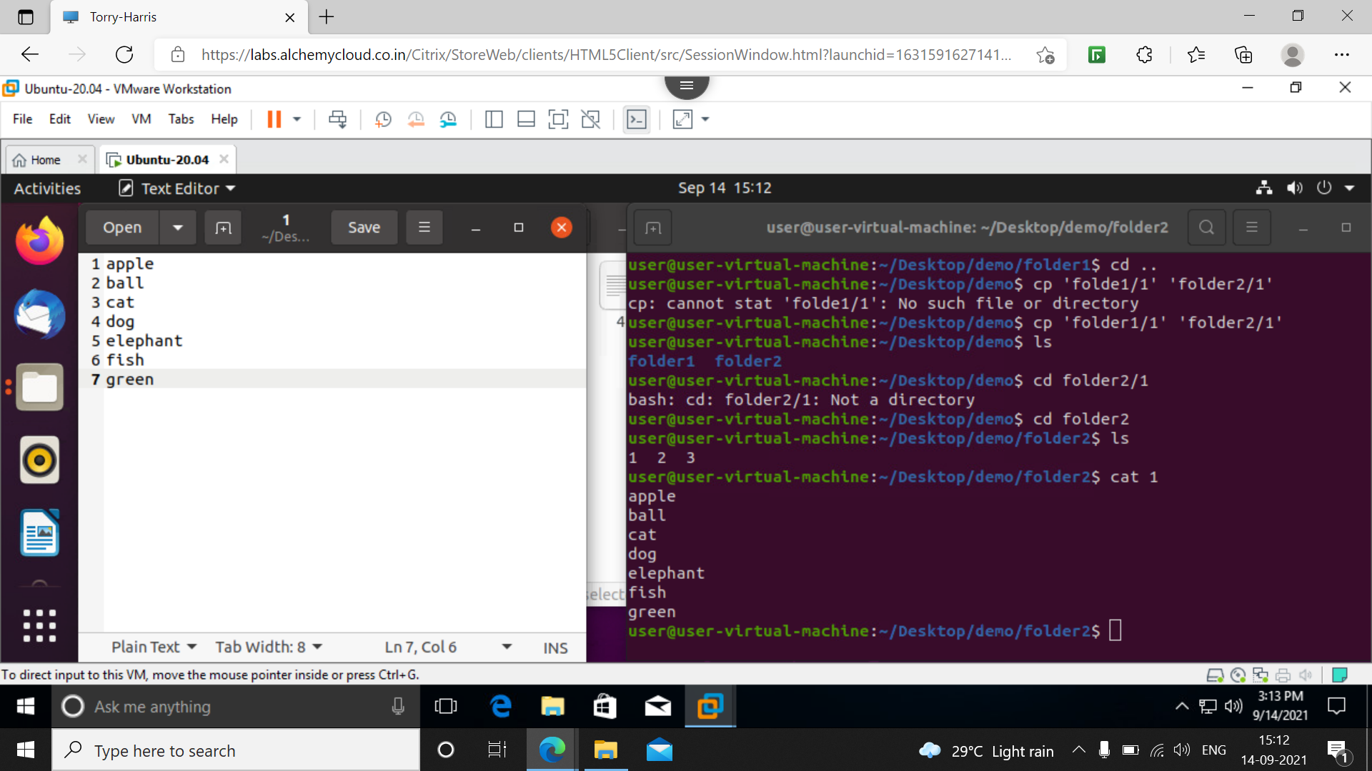

23] **mv** : used to move the file from one folder to other

Below I created a file in folder2/2 as teams name ind, aus, sl etc

After using mv command the data is moved to folder1 file 2 the screenshot shown

The file in folder2 moved to folder1 and the contents are read using cat 2 command

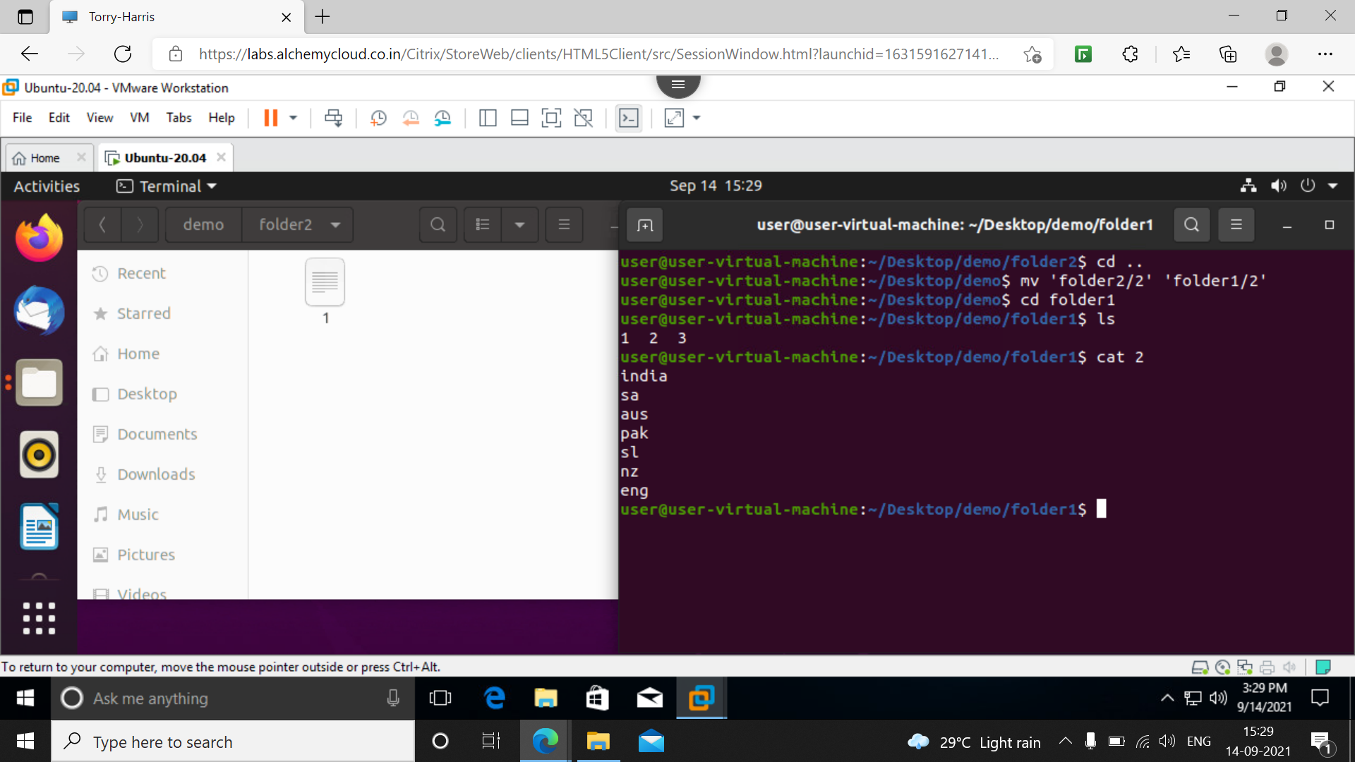

24] **cp** : copying from one file to other ( here eg, cp 1 4 mean copy the contents from 1 to 4th file )

Here in example folder1 had only 123 files I created a new file 4 then copied the data of 1 to 4 using cp 1 4 command and displayed the data of 4 using cat 4 the data is successfully copied and it is displayed.

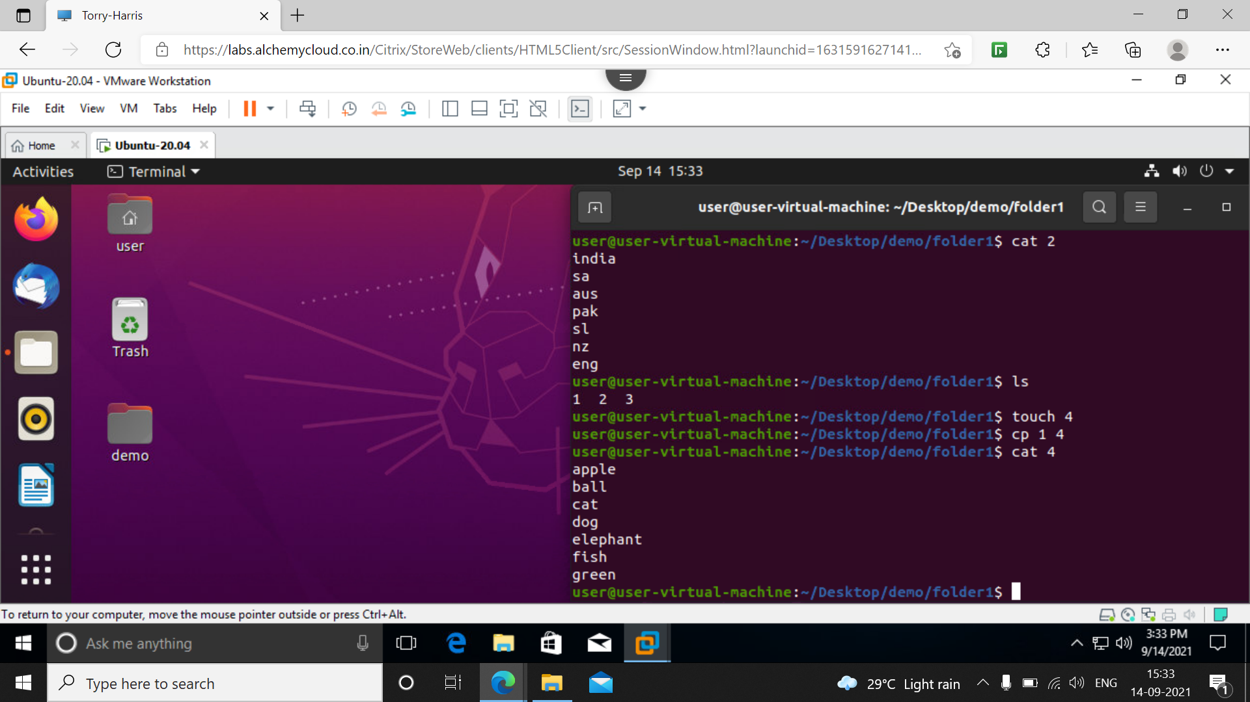

26] **tac** : tac command is used to print the data from last to first.

We can compare the cat 4 and tac 4 command for verification.

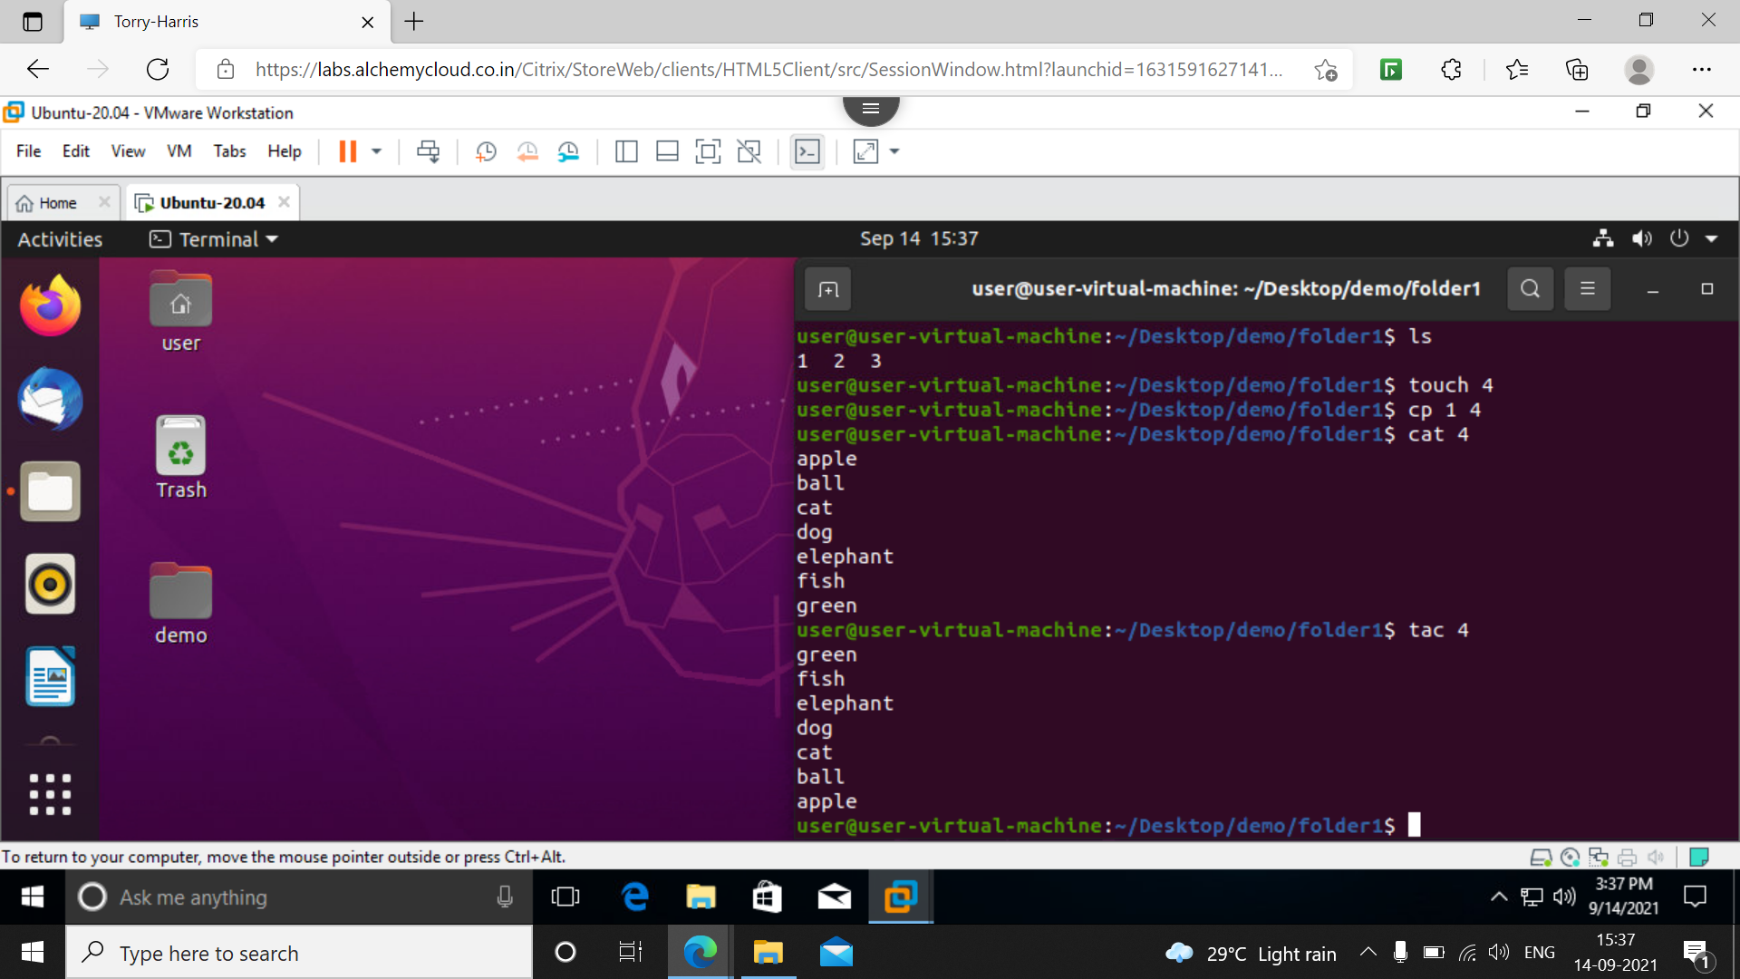

27] **sort** : it is used to sort the data according to the dictationary

In below we have list of teams after using sort all teams are sorted according to alphabetic order.

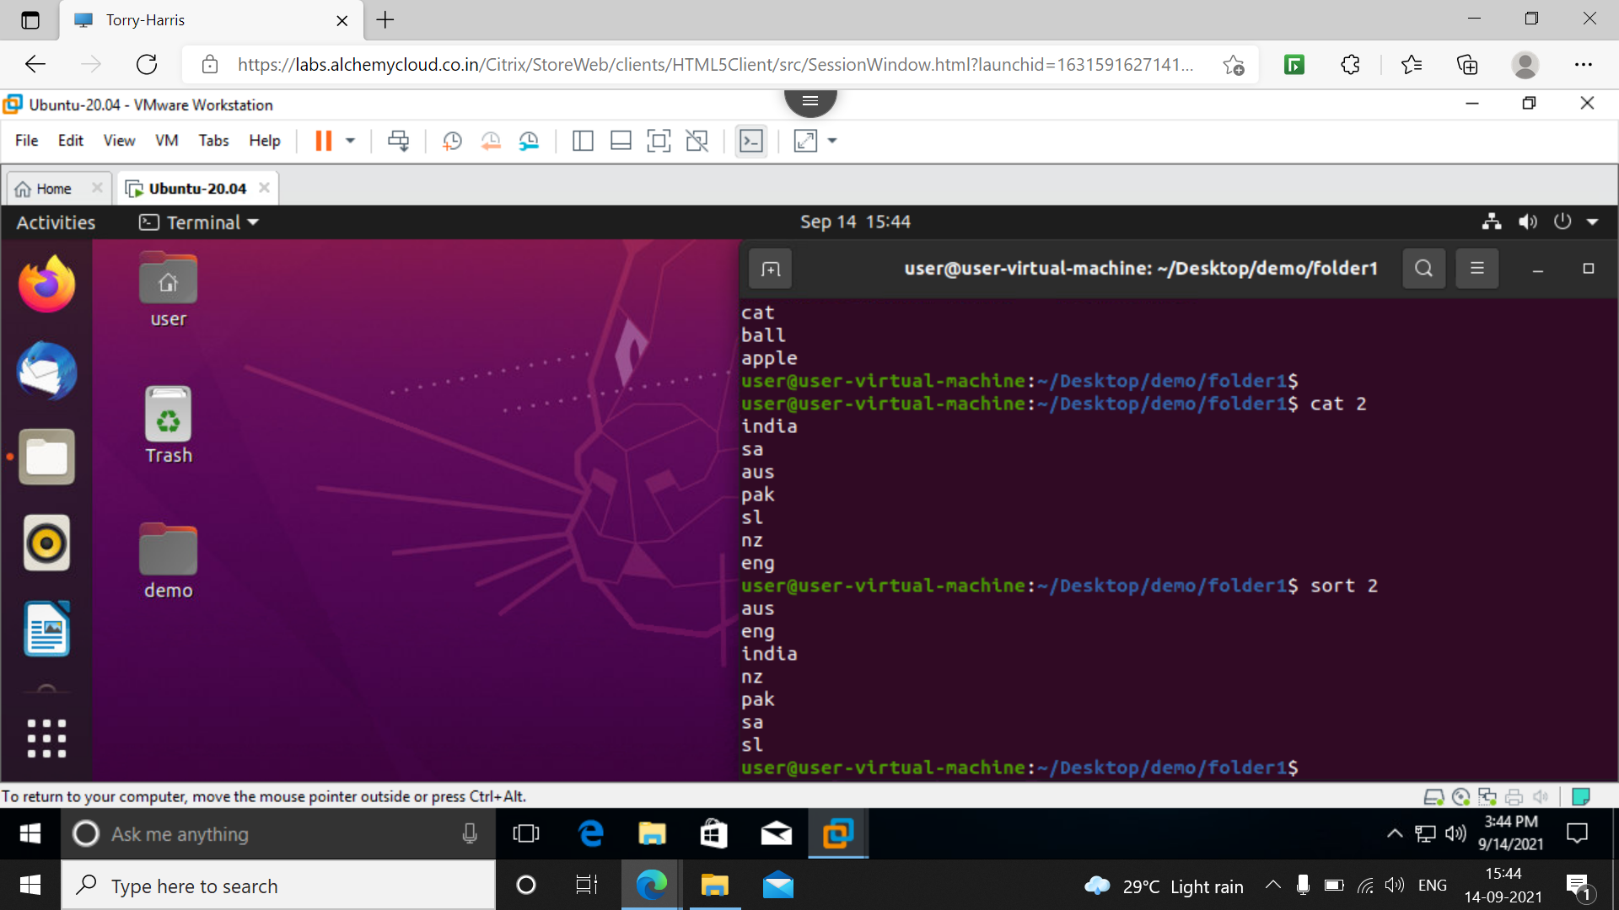

28] **cat 1 2 3**: to print all the data in 123 files

Below example all the data in file 1 2 3 is displayed after using cat command.

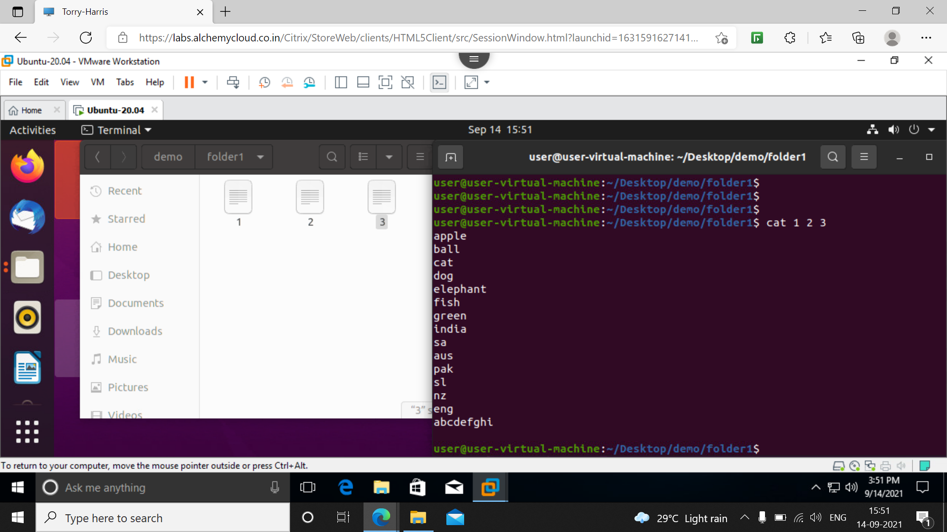

29] **cat –b filename** : using this it will give the numeric representation before the data

Below we can see the it will give the count here 7 count it has.

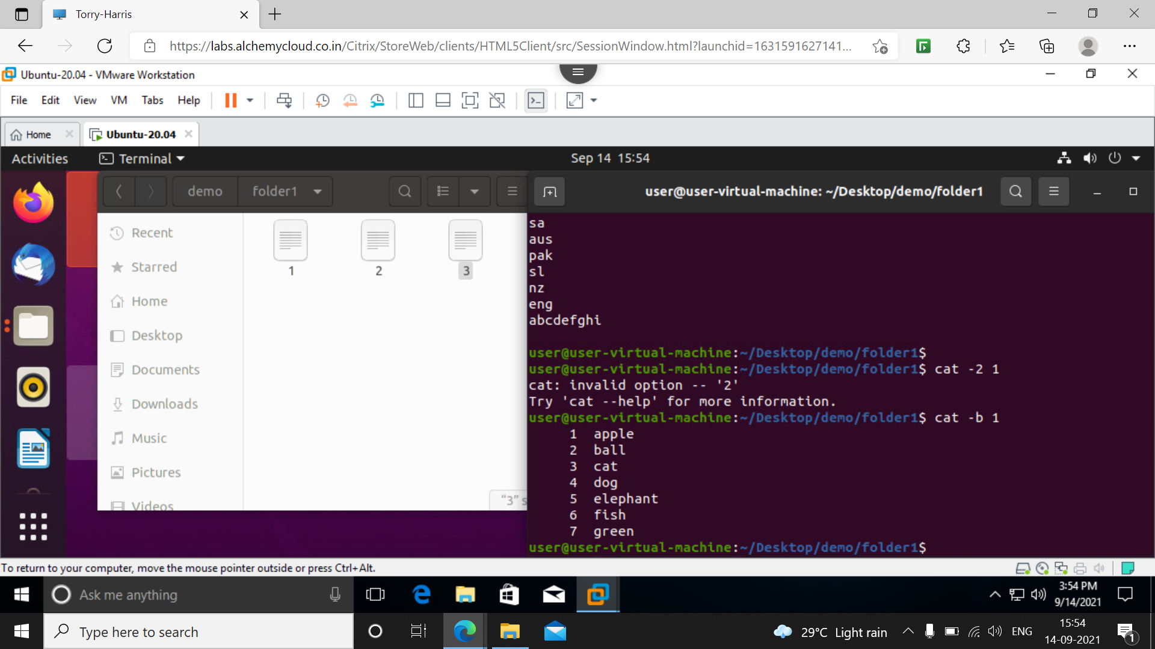

30] **mkdir -p new/1/2/3/4**: this command creates new folder inside 1 is created again inside 2 and so on

The main logic here is creating folder inside a folder here in homescreen we can see the new folder inside which 1 is created and so on

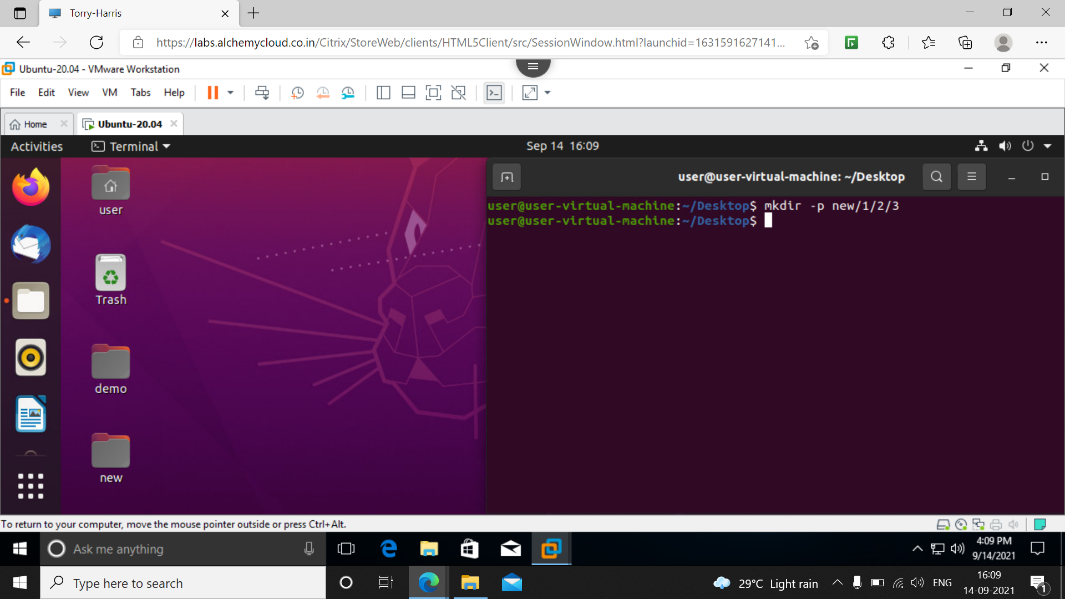

31] **rm –rf new** : this command deletes the newly created as in above example 30]

Here irrespective of no of folders inside it will delete them recursively

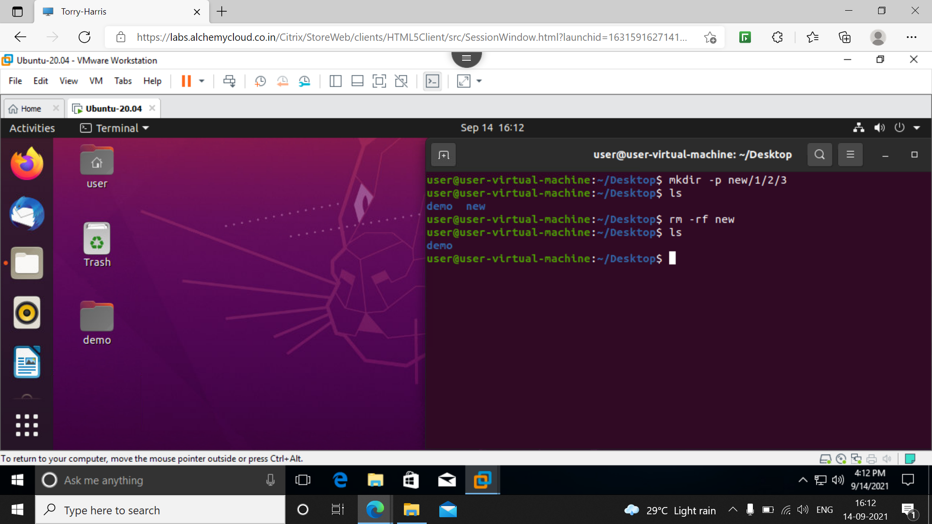

32] **ls –lr –a** : this gives the details regarding hidden files in recursive manner

33] **ls –lar** : we can use this also.

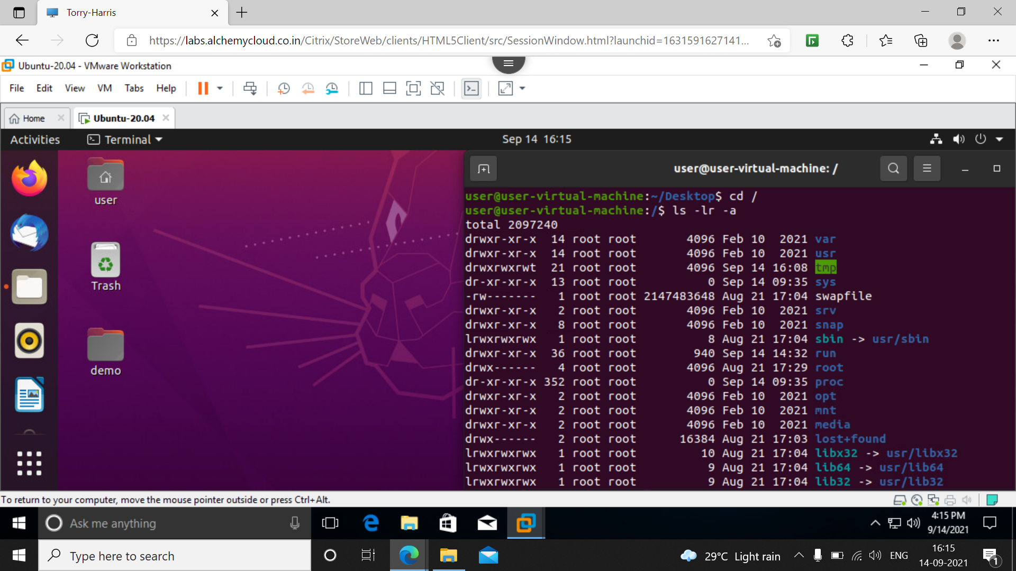

34] **passwd** : for changing the existing password of the user

It will ask for current password then new password and confirm password

Our password will be successfully updated.

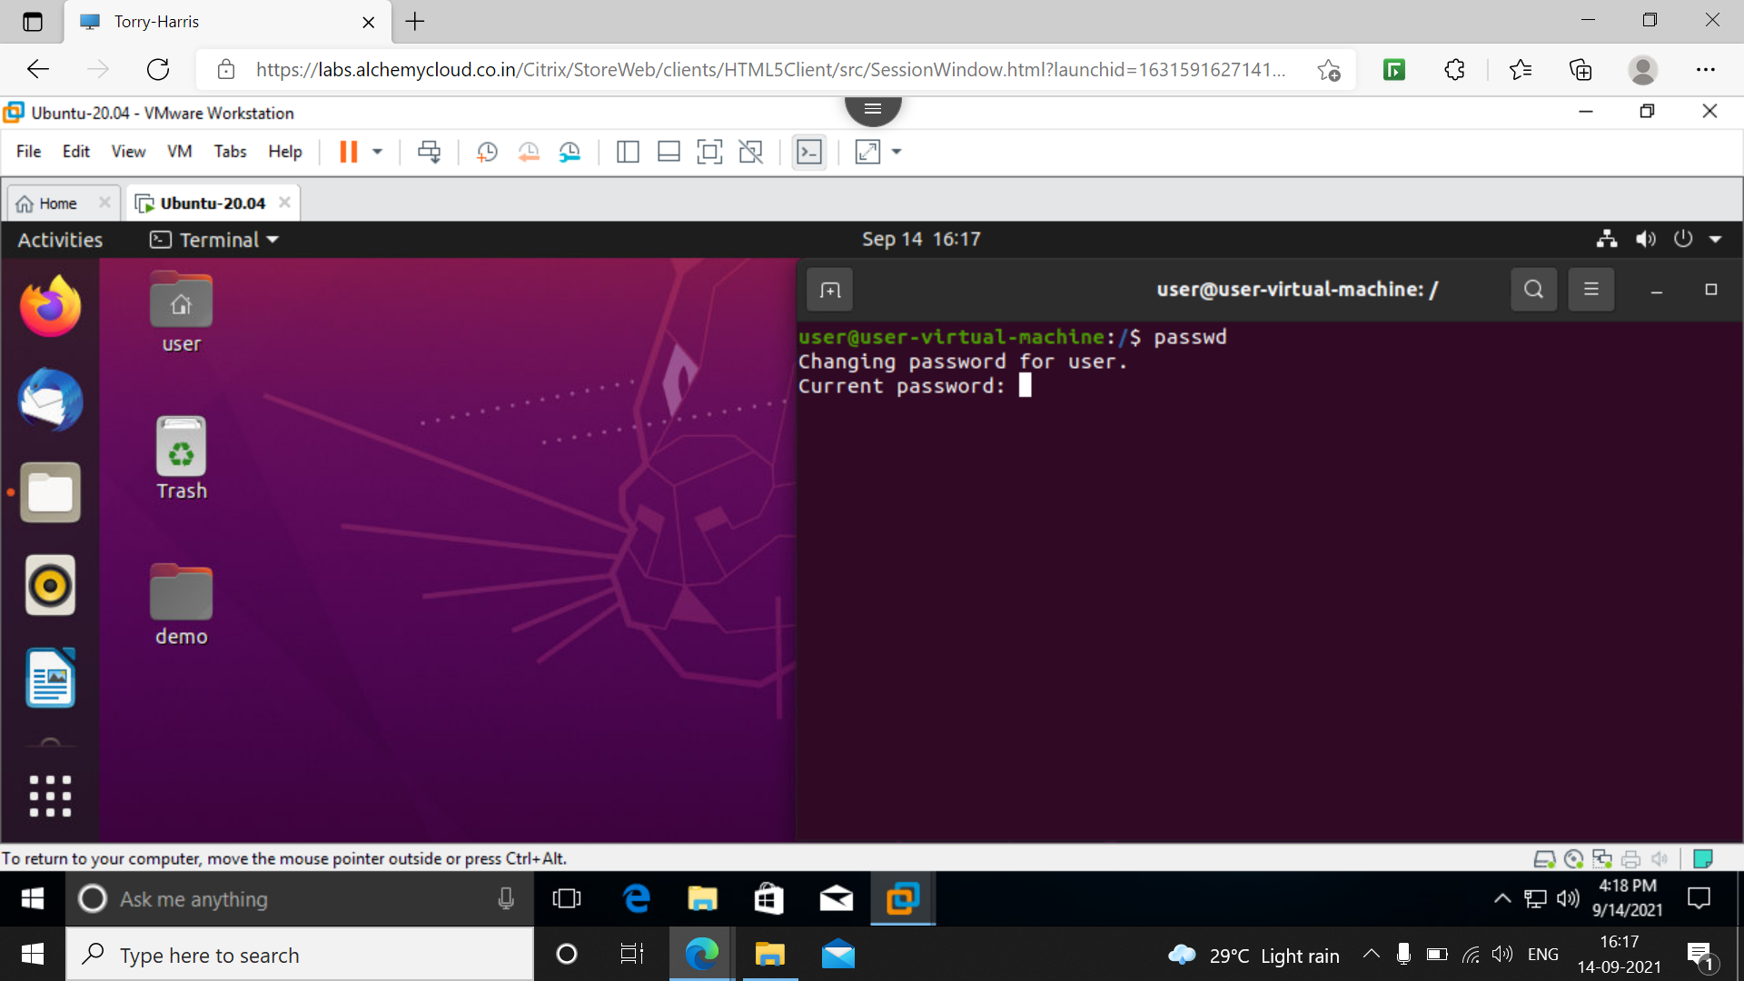

35] **tree**: this is used to see the hierarchical structure of current using directory

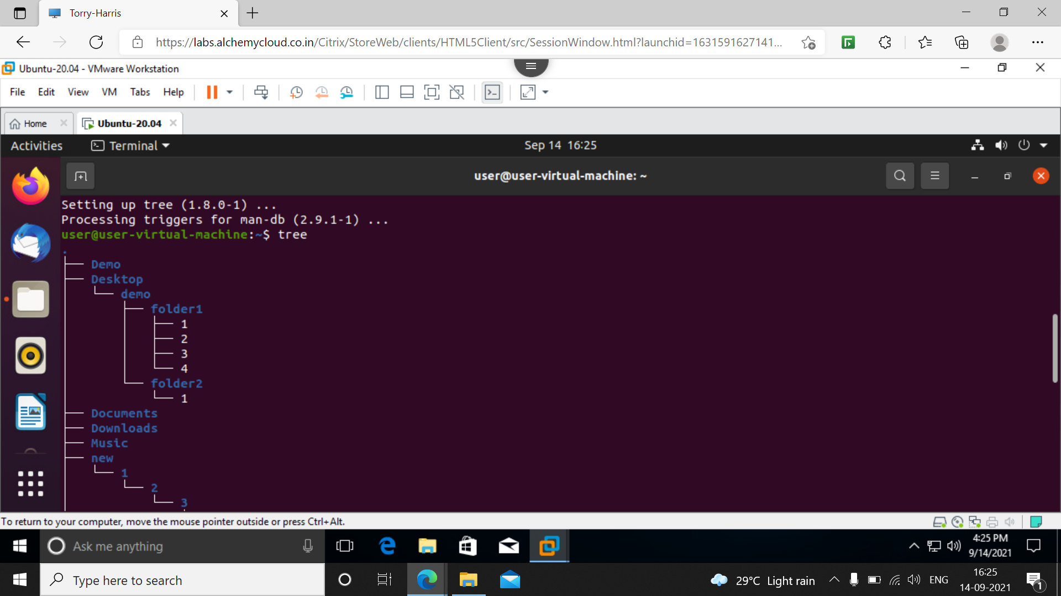

36] **tree installation** :

sudo apt install tree # version 1.8.0-1

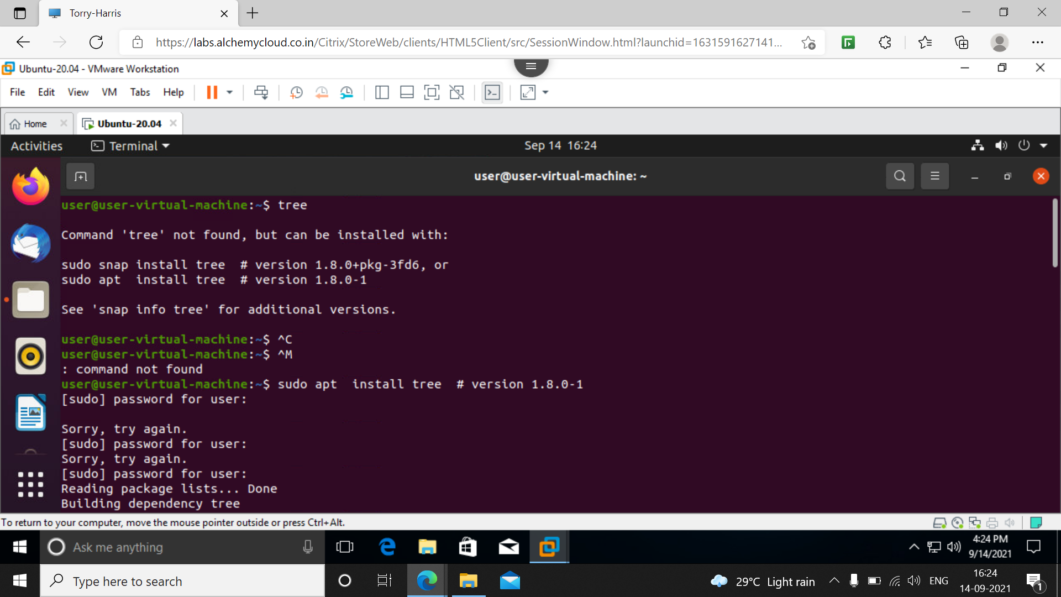

37] **tree –d** : this gives tree of only directories

In below I have only 17 directories after running command